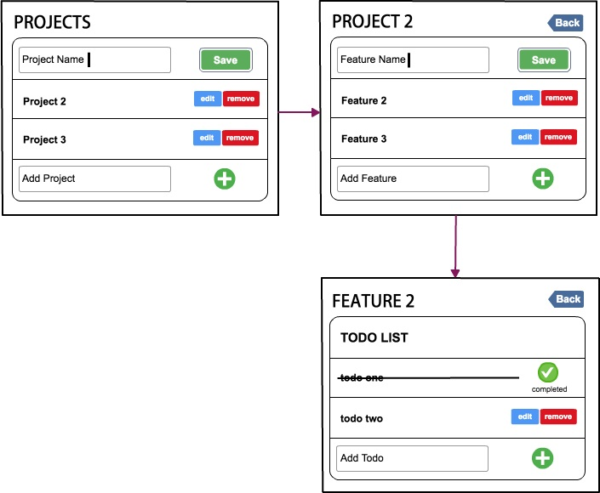

**Assignment**

The image as attached is a wire frame of a simple project management tool. The tool comprises of 3 related entities: projects, features and to-do list.

**Task one** is to identify the UI/UX issues within the wireframe and suggest how would you address those issues.

**Task two** is to implement the suggestions from task one and build this tool as a single page application (SPA) using **ReactJS** only. The tool is expected to do the following:

* Add, edit or delete projects
* View a project's features, and able to add, edit and delete them. Deleting a project should delete all features associated with it.
* View a feature's to-do list, and able to add, edit, delete and mark/unmark as completed. Deleting a feature should delete all to-do lists associated with it.

Bonus points:

* Filter projects, features and to-do lists
* Animation
* Sorting
* SASS preprocessor

Please complete this assignment by **21st March 2018 (Wednesday) by 5.00pm**.